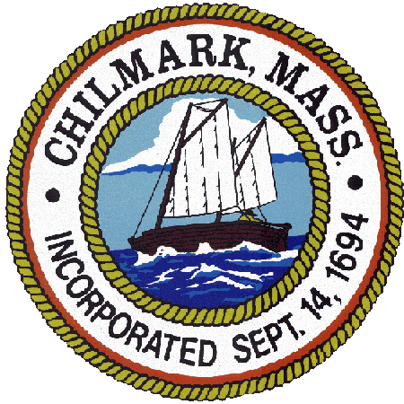

TOWN OF CHILMARK
FALL 2021 SPECIAL TOWN MEETING SCHEDULE

SPECIAL TOWN MEETING
Chilmark Community Center
520 South Road
SATURDAY, NOVEMBER 6, 2021
1:00PM

Last day and hour to submit final warrant articles to the Board of Selectmen for inclusion in the Special Town Meeting warrant.
Friday, September 17, 2021, 12:00 pm

Last day to post or publish warrant for Special Town Meeting
(14 days before Special Town Meeting):
Friday, October 22, 2021

Last day to register to vote for Special Town Meeting
(10 days before Special Town Meeting):
Wednesday, October 27, 2021
2:00 pm to 4:00 pm/ 7:00 pm to 8:00 pm

Register to vote online https://www.sec.state.ma.us/ovr/
Register to vote by mail https://www.sec.state.ma.us/ele/eleifv/howreg.htm
Register to vote in person: 401 Middle Road, Chilmark, MA 02535

Contact the Chilmark Town Clerk
508-645-2107
townclerk@chilmarkma.gov

_______________
Jennifer L. Christy,
Chilmark Town Clerk
September 22, 2021

