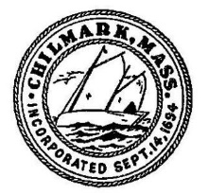
Building Permit Fee Waiver Form

The purpose of this form is to grant or deny permit fee relief. If approved, the total building permit fee shall either be waved entirely or shall in total be no more than $1000 not including all Electric/Plumbing/Gas permit and inspection fees as they are separate permits.
Applicant(s):

Affordable Housing/Owner Occupied Yes No

Year Round/Full Time Resident Yes No

Resident First Time Home Owners Yes No

Financial Hardship Yes No

Approved Denied

NOTES:

Select Board Members:
1.

2.

3.

