April 6, 2026
Explanatory Comments relating to determining whether a “story” is considered above grade or a basement.

Relevant proposed definitions.
Total Living Area: Total Living Area means the aggregate Floor Area of the horizontal areas of the Stories Above Grade Plane (and Basement Areas as indicated below) of a Building measured from the interior faces of the exterior walls of the Building, without deduction for bathrooms, hallways, stairs, closets, and the thickness of interior walls, columns or other structural features. (Note: This is the basic proposed definition without inclusions and exclusion lists)
Basement: A Story that is not a Story Above Grade Plane. (See Story Above Grade Plane)
Grade Plane: A reference plane representing the average of the finished or Natural Ground Level adjoining the Building at all exterior walls, whichever is lower at any given point.
Story: That portion of a Building included between the upper surface of a floor and the upper surface of the floor or roof next above.
Story Above Grade Plane: Any Story having its finished floor surface entirely above Grade, or in which the finished surface of the floor next above is more than six feet above Grade Plane.
Why do codes use “Story” rather then “Floor” to describe a level of a building.

A “floor” is just a thing; a “Story” is a defined space
- Floor is the surface you walk on. It doesn’t have height.
- Story is the vertical space between one floor and the floor (or roof) above
Codes regulate spaces, not just surfaces—so “story” is the useful unit. The TLA regulation is about volume and vertical stacking, not the walking surface. “Story” is used instead of “floor” because it’s a precise, controllable unit of building height and occupancy, while “floor” is just a physical element that’s too ambiguous for regulation.
And for our purposes, terms such as “Basement” and “Story”, etc. should align with building codes so as not to cause any confusion or conflicts.
Discussion: Defining a Story Above Grade Plane relative to the Story above.
What is the rationale for saying that a Story is above grade if the Story Above is more than 6' above grade plane.?
This rule comes from how building codes try to distinguish between basements (partly underground) and true above-ground stories, mainly for safety, light/ventilation, and fire protection.
In codes, a level is treated as a “story above grade plane” if the floor above it is more than 6 feet above the grade plane at any point (with averaging rules depending on the exact code section).

Why 6 feet?

It’s no longer really “underground” if the next story up is more than 6' above the surrounding ground, that means most of the story below is exposed, not buried.
- At that point, it behaves like a ground-level story, not a basement.
- Visually and functionally, it’s no longer “below grade.”

Why not 4 ft or 8 ft? 6 feet is a compromise:
- Less than 6 feet → still feels meaningfully below grade
- More than 6 feet → clearly above grade in human and functional terms
- Human-scale perception of “above ground”
Bottom line. The 6-foot rule exists to ensure that if a level functions and looks like a real above-ground story, it is regulated like one—regardless of what you call it. See the illustrated examples following.

Why the 6' number is “sticky”? Why shouldn’t we change the 6’ to 4’-6” or 5’ to capture more basements that look like an above ground story?
The 6' cutoff isn’t just arbitrary—it’s embedded in widely used model codes from the International Code Council as adopted (with amendments) in Massachusetts via the Massachusetts State Building Code.
That matters because:
- The State building code controls life safety (egress, fire separation, etc.)
- Local zoning cannot contradict the building code
- If our bylaw defines “Story Above Grade Plane” differently, we could end up with:
  - A level counted as a story under zoning
  - But still treated as a basement under the building code (or vice versa)
That mismatch could create confusion for:
- Building inspectors
- Designers
- Zoning boards
- And, ultimately, enforcement

What happens if we did go ahead and lower it to 4'-6" or 5’?

Potential benefits are that we’d catch more “walkout basements” that are really:
- Fully habitable
- Mostly exposed on one side
- Functioning like a true first floor
So yes—it would reduce gaming of the definition.
But the downsides are we’d be deviating from the standard used everywhere else.
- Architects and builders rely on consistent definitions
- Appeals and disputes become more likely

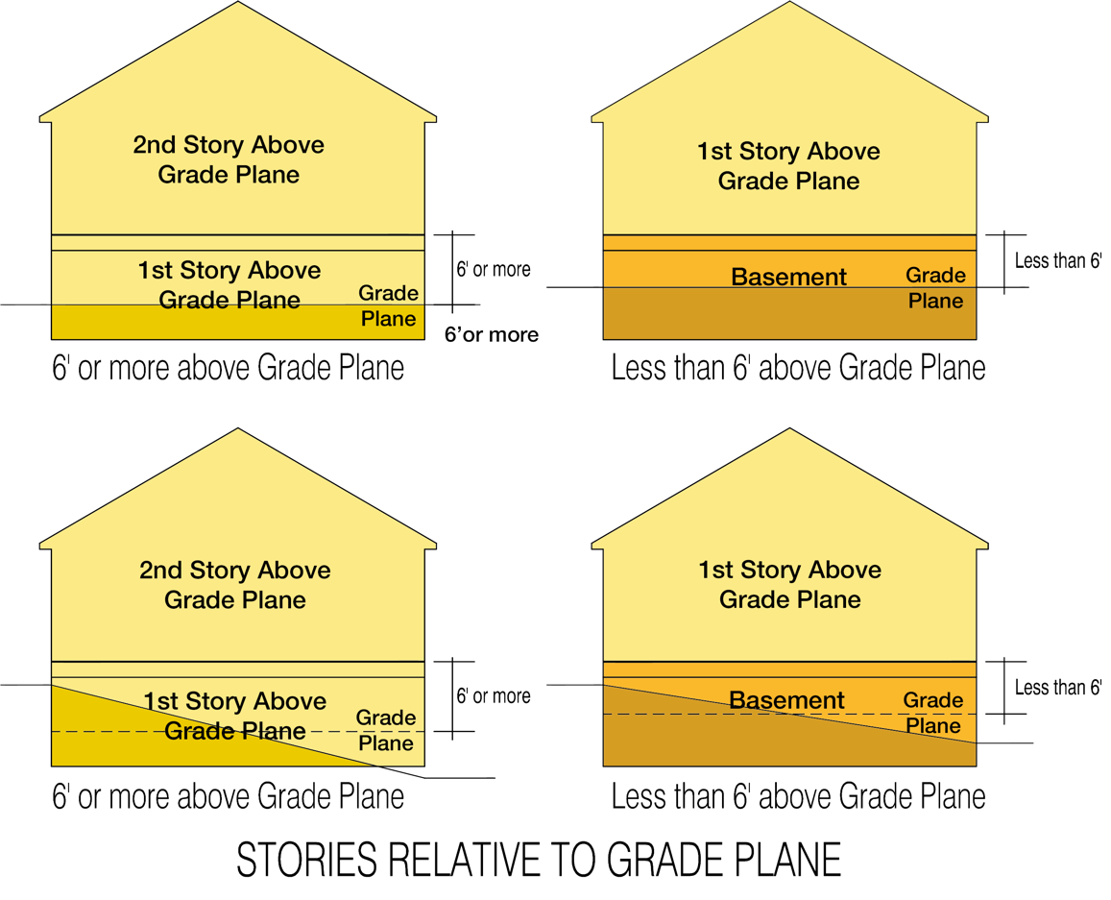
Capturing Basement areas as TLA when functionally a Story Above Grade.

So yes, we should Keep the 6' rule for alignment with the building code and add targeted criteria that capture when a “Basement” or portion thereof is functionally like a Story Above Grade.
What people are really doing when they “game” basements is:
- Creating bright, comfortable, fully usable rooms
- While trying to keep them from counting as TLA
Windows are a strong proxy for that because:
- Large window area → daylight + habitability
- Often correlates with walk-out conditions
- Signals intent to use space as living area
Allowing a certain area of windows, where above that, space is counted as adding to TLA is….
- Objective
- Hard to game
- Easy to measure from plans
We should count Glazed area only of windows and doors (not rough opening) above adjacent grade regardless of whether they’re in wells or such and tie it to conditioned space(s). Also, it’s important to also state that such areas are included regardless of finish and stated use to prevent gaming by labeling an area as something like “storage” and then finishing the area and changing its use after completion.
Therefore, the following is included in the proposed list of areas included in TLA:
b. Conditioned Basement areas that have more than 50 square feet of glazed area in total for all such areas and such areas are designed for potential regular human occupancy regardless of finish level and stated or labeled use.

