

June 21, 2022

Nancy Grundman

Chilmark Community Center

520 South Rd,

Chilmark, MA 02535

Phone: (914) 394-8384

Email: ngrundman1@gmail.com

**Base Project: Repair and Resurface Tennis Courts (1440 SY)**

*Scope of work and product specifications attached*

1. Repair asphalt cracks with Riteway repair system (164 LF including extensions)
2. Fill hairline cracks with silicone
3. Resurface courts with 3 coat Plexipave System

Colors chosen by owner: __Dark Blue _inbounds, and _Dark Green__outbounds.

**Price: $20,750.00**

**Option 1 – Install 2 new nets**

**Price: $600.00**

If you would like to accept this option, please initial here ________

**Option 2 – Paint 2 sets of pickleball lines while on site**

**Price: $1,200.00**

If you would like to accept this option, please initial here ________

**Scope of work and product specifications**

We propose hairline crack repair when the cracks are 1/8" wide or less. The product we use is paintable silicone or equal filler. The only warranty we can offer with this type of sealing is one covering the same playing season as the installation. Often these hairline crack will develop into larger structural cracks and at that time we can propose the RiteWay crack repair system with the 2-year warranty.

**RiteWay Crack Repair System**

*Note: the membrane system we recommend has to be applied when sunny and temperatures are at least 60 degrees. It cannot be done early in the spring or late in the fall.*

RiteWay Crack Repair System utilizes a three-membrane system and includes 2 year warranty, something very unusual in the crack repair business. **By “extending” the membrane three feet beyond the end(s) of the actual cracks, it will take some time for the existing cracks to grow beyond the membrane.** *Be aware that this will not prevent cracking elsewhere on the court surface so random cracks may still appear in other areas.*

Open, clean and fill the cracks using Court Patch Binder mix.

Apply RiteWay Crack repair to structural cracks

*We warranty the RiteWay Crack System to the extent of the membrane repair for two years. We do not warranty or guarantee the crack beyond the actual repair. The cracks may continue to grow over time and new cracks may appear for the first time at a later date. We also do not warranty the filling of any puddles (birdbaths) if proposed. We do not warranty cracks around net posts or center anchors; they expand at a different rate than asphalt does. It is also possible to see the edge of the membrane repair after resurfacing*

**Please Note:** Due to the volatility in both availability and cost of construction materials, all pricing is subject to increase without notice

Surfacing

**The Plexipave Coloring System, manufactured by California Products of Andover, Massachusetts shall be applied.**

Apply one coat of Acrylic Resurfacer; this is a heavy filler coat which provides an excellent texture for a base coat.

Apply two coats of Colored Fortified Plexipave These coats provide the court with a uniform surface texture.

Layout, tape and hand paint lines per USTA specifications.

*Please Note: If at the time the work is to be performed, the tennis court has algae, excessive mildew, or additional excessive dirt that was not present at the time of estimation, there will be a $1,500.00 charge to pressure wash the court to assure proper adhesion of both the crack repair material and the new tennis surface.*

*Please Note: Do not use black-soled shoes. Use only flat- soled (no knobs) tennis shoes. Hockey sticks, black soled sneakers, roller blades, bike tires and skateboards will mark or damage the court surface. If you use tables, benches or chairs on the court, use coasters under the legs to spread the weight, so that the court doesn’t get damaged. Do not walk on the court with high-heeled shoes. It is possible to see banding or tool marks in the finished surface. This is within norms of industry standards.*

**Payment Schedule to be as Follows:**

First payment of 40% upon approval and acceptance of contract.

Balance to be paid upon completion.

All material is guaranteed to be as specified. All work to be completed in a workman like manner according to standard practices. Any alteration or deviation from the above specifications involving extra costs will be executed only upon written orders, and will become an extra charge over and above the estimate. All agreements contingent upon strikes, accidents or delays beyond our control. Owner to carry fire, tornado and other necessary insurance. The contractor agrees to carry Workmen’s Compensation and Public Liability Insurance required by the United States Government and the state in which this work is to be performed.

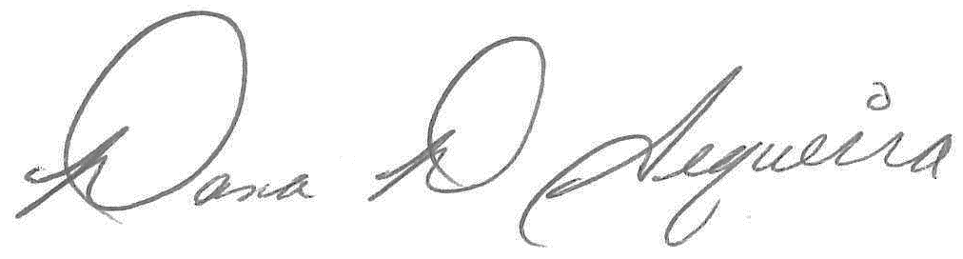

Authorized Signature: ______________________________________ Date: 8/15/2022

**Dana Sequeira, Tennis Division**

Acceptance of Proposal

If the foregoing meets with your acceptance, kindly sign and return the attached copy of our proposal. Upon its receipt it is understood the foregoing, including the terms and conditions set forth above, will constitute the full and complete agreement between us.

Authorized Signature: __________________________________ Date: ______/_____/______

This contract expires thirty days from the date hereof, but may be accepted at any later date at the sole option of Cape and Island Tennis & Track.

Note: Your account will be subject to a service charge of 1.5% per month (18% per annum) on all invoices not paid within our normal payment term.

**Please indicate billing contact information if different than the information above:**

**Name:**

**Address:**

**All scheduling questions should be directed to Brando Sequeira at 508 759 5636 or** [**bsequeira@tennisandtrack.com**](mailto:bsequeira@tennisandtrack.com)